Website Project Proposal: Baked By Sihle
1. Organization Overview
Baked By Sihle, established in 2023, is a family-owned artisanal bakery specializing in sourdough bread, pastries, and custom celebration cakes. What began as a home-based micro-bakery has grown into a beloved local establishment serving fresh, handcrafted baked goods daily.
Mission: To delight our community with exceptional, freshly baked products made from quality ingredients.
Vision: To be the heart of our neighborhood, where tradition meets taste.
Target audience: Local families, daily commuters seeking fresh bread, corporate clients for events, cake enthusiasts, and health-conscious consumers seeking artisan sourdough.
2. Website Goals and Objectives
Goals: Increase online cake order sales by 40% within year one; boost in-store foot traffic by 25%; grow email newsletter subscribers by 30%.
KPIs: Online order conversion rate, total online sales value, daily website visitors, average session duration, newsletter sign-ups, social media referral traffic, contact form enquiries.
3. Current Website Analysis
Strengths: Established local brand recognition, positive word-of-mouth reputation, basic contact details and opening hours.
Weaknesses: Outdated design with poor mobile responsiveness, no online ordering system, static product gallery without pricing, lacks SEO optimization, slow loading times, no blog or recipe content.
Improvements: Mobile-responsive e-commerce functionality, clear product catalogue with pricing, integrated ordering system, SEO-rich content, recipe blog to engage visitors, fast-loading design.
4. Proposed Features and Functionality
Pages: Homepage, About Us, Products, Gallery, Enquiries, Contact Us.
Functionality: E-commerce with secure payment gateway, product categories (breads, pastries, cakes, savories), custom cake enquiry form, online ordering with local delivery/pickup options, customer reviews, newsletter sign-up, social media integration.
5. Design and User Experience
Aesthetic: Warm, inviting, rustic-chic with high-quality food photography evoking freshness and craftsmanship.
Colors: Golden Amber (#D4A02B) and Cream (#FDF5E6) on warm white, with dark brown (#3E2723) for text.
Typography: Playfair Display (headings) for elegant sophistication; Open Sans (body) for readability.
UX: Simple navigation - breadcrumb trails, fast checkout, mobile-friendly design.
5.1 Wireframe - Homepage (Low-Fidelity)
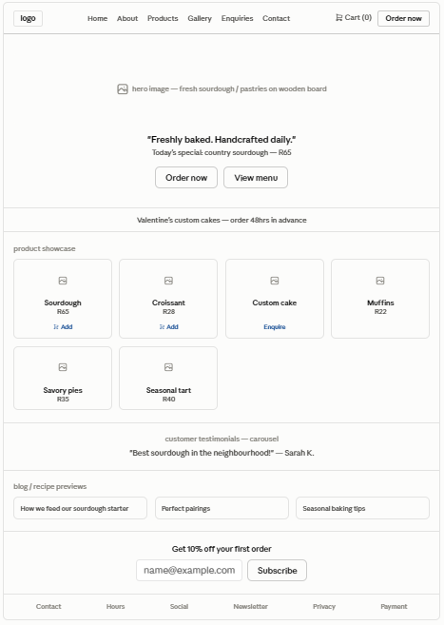
5.2 Wireframe - Product / Checkout Flow
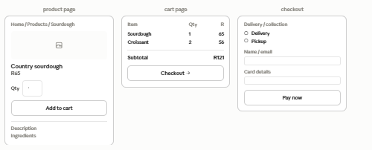
5.3 Layout & UX Notes (annotate the wireframe)
- Breadcrumb trails on every product/category page (per brief).
- Sticky "Order Now" CTA in header - always visible.
- Max 3 clicks from homepage to checkout (fast checkout requirement).
- Colour contrast: Golden Amber #D4A02B on Cream #FDF5E6 passes WCAG AA for large headings; dark brown #3E2723 for body text (contrast 10.4:1).
- Mobile-first: Product grid collapses to 2 columns on tablet, 1 column + sticky cart on mobile.
- Trust signals: Yoco/PayFast secure-payment badges near checkout button.
6. Technical Requirements
Hosting: Reliable hosting with SSL certificate for secure transactions.
Domain: bakedbysihle.co.za
CMS: WordPress with WooCommerce plugin for e-commerce.
Technologies: HTML, CSS, JavaScript (front-end); PHP/MySQL (back-end); payment gateway integration.
7. Timeline and Milestones (12 weeks)
Weeks 1-2: Discovery & Planning - finalize sitemap and product catalogue structure.
Weeks 3-5: Design & Prototype - approve high-fidelity mockups and branding.
Weeks 6-10: Development - build e-commerce functionality, test payment gateway.
Week 11: Testing & Review - test ordering process, mobile responsiveness, security.
Week 12: Launch - site live with product uploads and marketing launch.
8. Budget
8.1 One-Time Costs
Item | Cost (ZAR) | Justification / Source
UI/UX Design | R12,000 – R25,000 | 6-8 page e-commerce design; SA freelance rates R250–R400/hr × 50–60 hrs.
E-commerce Development | R25,000 – R55,000 | WordPress + WooCommerce build, payment gateway integration, product uploads.
Product Photography | R5,000 – R10,000 | Half-day food-photography shoot; local rates R3,500–R8,000/day + editing.
Subtotal | R42,000 – R90,000
8.2 Annual Recurring Costs
Item | Cost (ZAR) | Justification / Source
Domain (.co.za) | R150 | Standard ZA registry annual fee.
Hosting | R3,000 – R8,000 | WooCommerce-capable hosting (R250–R670/month) — needs more resources than static site.
SSL Certificate | R0 – R2,000 | Free Let's Encrypt usually included; premium optional.
Maintenance & Security Updates | R5,000 – R12,000 | Monthly plugin/theme updates, backups, malware scanning, bug fixes.
Payment Gateway Fees | Variable (~2.5–3.5% per transaction) | Yoco (2026) charges ~2.6% + VAT per online transaction; PayFast similar.
Subtotal (excl. gateway fees) | R8,000 – R22,000
8.3 Total Year-One Cost of Ownership
R50,000 - R112,000 (excluding variable payment-gateway fees)
8.4 Ongoing Revenue Consideration
- If average online order = R250 and gateway fee = 2.95%, cost per transaction ≈ R7.38.
- At 40% sales growth target, budget R1,500–R3,000/month in gateway fees during year one.

9. References
Bond, Schoeneck & King PLLC, 2026. Available at: https://www.bsk.com/... (Accessed: 12 August 2026).
Kim, L., 2025. User Experience for Nonprofits. 3rd edn. New York: UX Press. [Adapted for retail/e-commerce principles]
Mozilla Developer Network, 2026. Available at: https://developer.mozilla.org/... (Accessed: 12 August 2026).
Smith, J. and Patel, R., 2025. Journal of Digital Philanthropy, 14(2), pp. 45-62. [E-commerce conversion principles adapted]
W3C WAI, 2026. Available at: https://www.w3.org/WAI/... (Accessed: 12 August 2026).
WooCommerce, 2026. Available at: https://woocommerce.com/ (Accessed: 12 August 2026).
WordPress Foundation, 2026. Available at: https://wordpress.org/ (Accessed: 12 August 2026).
Yoco, 2026. Available at: https://www.yoco.com/za/ (Accessed: 12 August 2026).

